02.09 Airworthiness Certificate
Process Design & AMOS Configuration Document
Purpose
This Process Design document is provided to Key-Users to record their key decisions regarding the AMOS Process design and the required AMOS configuration.
It is updated throughout the Project Definition Phase and used as the baseline for the Final Acceptance prior to Go-Live
Revision
Author, Name | Date | Notes
Jakub Sadowski | 01.12.2024 | Edition 24.12 – includes improvements of process diagram

Table of Contents
1. Process Overview & Objectives 3
2. Regulatory References 3
3. Definitions & Glossary 3
4. Process Tasks 4
5. Process Dependencies 4
6. Process Flow 5
7. Process Design Questions 6
8. Data Source Mapping 7
9. Other Software Used 7
10. AMOS Configuration 8
a. Process specific configuration programmes 8
b. Basic Data 8
c. Parameters 8
d. Workflows 8
e. Scheduled Tasks 8
f. API’s & Interfaces 8
11. UAT Guidance 9
12. Annex – Additional Info 10

Process Overview & Objectives
Process General Description:
AMOS can support process of ARC extension/renewal process as a tool for carrying out necessary inspection in accordance with raised Work Order, managing the findings and producing supporting documents/reports.
Certificates of Airworthiness are accompanied with Airworthiness Review Certificates, usually valid for 3 years since issue date (iaw EASA regulation). The validity of an ARC may be Extended provided that the aircraft has remained in a Controlled Environment under Part M for 12 months prior to ARC expiry.
The Operator may decide to use AMOS to plan and execute ARC extensions and ARC renewals as a plannable Document, ad-hoc JIC or Block Task Card within AMP, as the software does not force any particular solution for planning.
Main Process Objective (Outputs & Outcomes):
Control the ARC revision for full fleet within AMOS.
Review Data sources from AMOS for the ARC packs.

Regulatory References

M.A.707 Airworthiness review staff
b) Airworthiness review staff nominated by the approved continuing airworthiness organisation can only be issued an authorisation by the approved continuing airworthiness organisation when formally accepted by the competent authority after satisfactory completion of an airworthiness review under the supervision of the competent authority or under the supervision of the organisation's airworthiness review staff in accordance with a procedure approved by the competent authority.
M.A.710 Airworthiness review
When the organisation approved in accordance with point M.A.711(b) of this Annex (Part-M) performs airworthiness reviews, they shall be performed in accordance with point M.A.901 of this Annex (Part-M) or point ML.A.903 of Annex Vb (Part-ML), as applicable.

Definitions & Glossary
Key-Words | Explanation
ARC | Airworthiness Review Certificate
ARS | Airworthiness Review Staff
CAME | Continuing Airworhiness Management Exposition

Process Tasks

Perform ARC inspection – depending on work instructions and Company’s policy, the ARC inspection could include full scope inspection only during renewals (issuing new ARC), or split the effort to include inspections also during ARC extensions. This relies on ARC procedure approved by competent authorities in CAME or equivalent document.
Manage findings – flow involving technical and non-technical personnel other than ARS, who shall react to raised findings by carrying out corrective actions (together with preventive actions and root cause analysis, if required by internal procedure), and reach acceptable state before ARC is renewed – all NCs closed or exempted from stopping its issuance, if the finding is minor and does not affect airworthiness (depending on approved procedures for ARC renewal).

Process Dependencies
INPUT | CONCURRENT | OUTPUT
03.02 Planning  03.09 Work instruction authoring  04.03 Training and Qualifications | 01.03 Maintenance Program  01.04 SB&AD Assesment  01.05 Configuration Management  01.07 Reliability  01.08 Weight & Balance  02.07 Structural Damages  02.08 Digital Records  04.02 Maintenance agreements  04.06 Recurrent Defects  08.03 Defect Reporting and Deferral | 03.03 Reporting Back

Process Flow
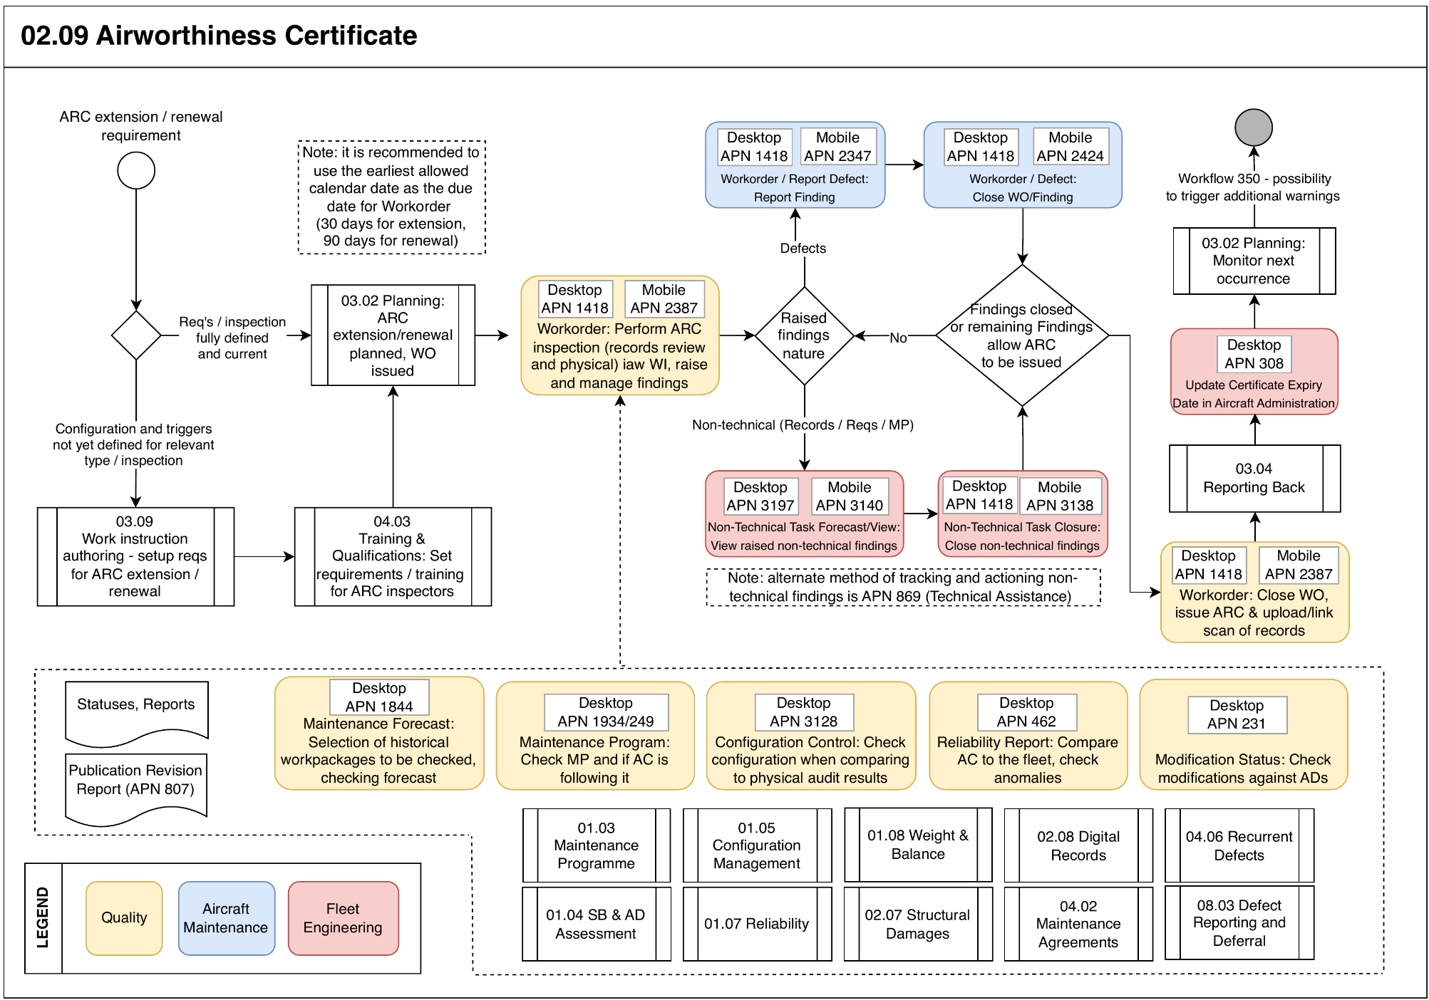

Process Design Questions
# | Question | Answer
 | Would you use AMOS to track qualifications and training (including recurrent training and experience continuity requirements)?
Is there a Technical Records department in your company?
What is their current responsibility?
Data entry?
Data auditing?

Would ARS personnel have direct access to these experts and rely on them for provision of data for ARC inspection, or would access be granted for them to work independently with relevant APNs?
 | Who is (who will be) responsible for the data entry of Defects? Label booking?
 | Hard copies;reports and dirty fingerprints storage control - what control is used today in your organisation?
Are you using a digital archive system?
If yes - will you interface with AMOS?
 | How will you manage your ARC renewal? Digital format of hard copy stored per aircraft?

Data Source Mapping
Data Sources | Description | Volume / Manual / Automatic / Static / Dynamic
-/- | -/- | -/-

Other Software Used
Other Software | Used by: | Description
-/- | -/- | -/-

AMOS Configuration

Process specific configuration programmes
AMOS APN | Notes
N/A | Process builds up on input processes, without additional AMOS configuration requirements. Work instructions, planning and production configured as per their respective BPDs.

Basic Data
Basic Data Table | Notes
N/A

Parameters
Parameter Code | Parameter Name | Notes
N/A

Workflows
Workflow Number | Workflow Name | Workflow Setup Notes
101 | Workorder issued | Recommended for smaller teams / fleets, where ARS personnel might be involved in other activities – Inform ARS personnel on a raised ARC W/O to allow resource allocation

Scheduled Tasks
Scheduled Task Reference | Frequency | Notes
N/A | - | -

API’s & Interfaces
Reference | Direction | Trigger | Frequency
N/A

UAT Guidance
Test case number | Test case description | Required data | Required resources
T02.09.01 | Produce ARC renewal dates
T02.09.02 | Produce airworthiness status reports
T02.09.03 | Perform ARC Inspection

Annex – Additional Info

-

